

**USER GUIDE**

**GLOBAL SCREENING DATABASE**

**VERSION 1.2.2**

# What is Screening?

The HR Services unit includes critical responsibilities such as managing global screening compliance with Data Protection standards and other legal/benchmarked standards in order to ensure IRW is clear of staff with any illegal, criminal, fraudulent or terrorist background, hence protecting the organization from legal and reputational risks and doing its due diligence.

# Importance of Screening Our Employees

Pre-employment screening can provide some assurance that a prospective employee is trustworthy and has the necessary skills and/or experience required to perform the role they have applied for. Screening helps in detection of thieves, fraudsters, illegal workers, terrorists and other individuals that do not have our best interest at heart and are a major concern.

The implications for our organization of employing someone who fits into the above is not only a serious inconvenience to our time and costs but also could be damaging for our reputation and image.

# Who Are Thomson Reuters?

A system that allows users to screen names, typically new or prospective customers against a watch list. They are a leading source of intelligent information for the world businesses and professionals, providing customers with competitive advantage.

# Flow of System

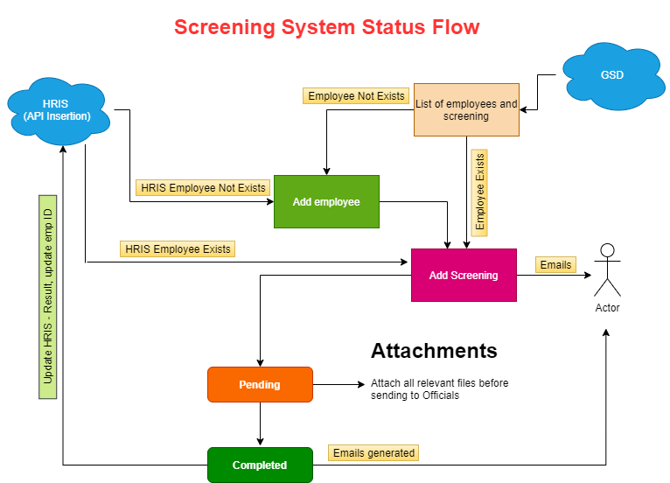

Figure : System Flow

Staff or volunteer record add to the system once (if system found as leaver employee then no need to add employee again), after that new screening data enter along job title and department details by all field offices before any job offer or agreement is made, and must only be offered once IRW Headquarters have screened and cleared the individuals.

Initially screening enter to ‘pending’ status and email alert send to higher management. Employee data check from Thomsan Reuter system and update screening result and marked as screening ‘completed’ in this system by internal HR person. And, this information updated in HRIS as well.

Same process go on, and if employee left, then mark employee as leaver and when in future again the same employee join then only screening detail will enter instead.

Table of Content

What is Screening? 2

Importance of Screening Our Employees 2

Who Are Thomson Reuters? 2

Flow of System 3

Main Module 5

User Roles and Access of Module 6

Login and Forget Password 7

8

Dashboard 8

Settings Menu 9

• Department, Region, Field Office and Job Title: 9

• User Management 10

Screening System 12

1. Add Employee 14

2. View Employee Details 14

3. Add New Screening 16

4. Attachments 19

5. Mark Completed Status 20

Mark Leaver 23

Email Alerts 23

# Main Module

* Login and forget password
* Dashboard
* User Roles (Administrator, Operator, Viewer)
* Settings
* Employee Screening

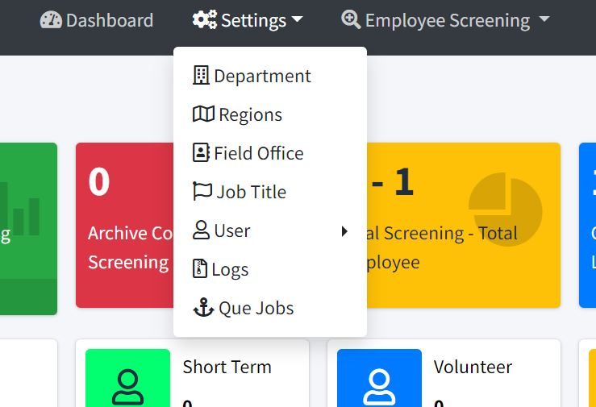

Figure : Setting

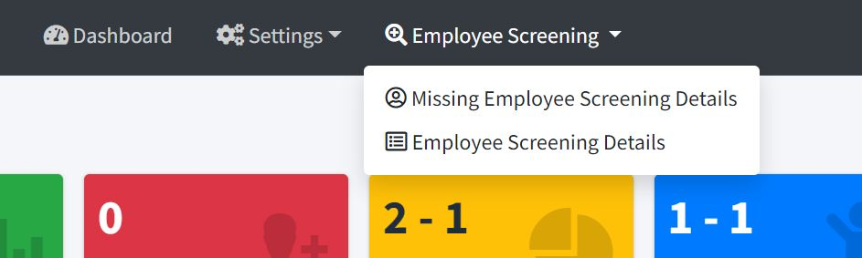

Figure : Employee Screening

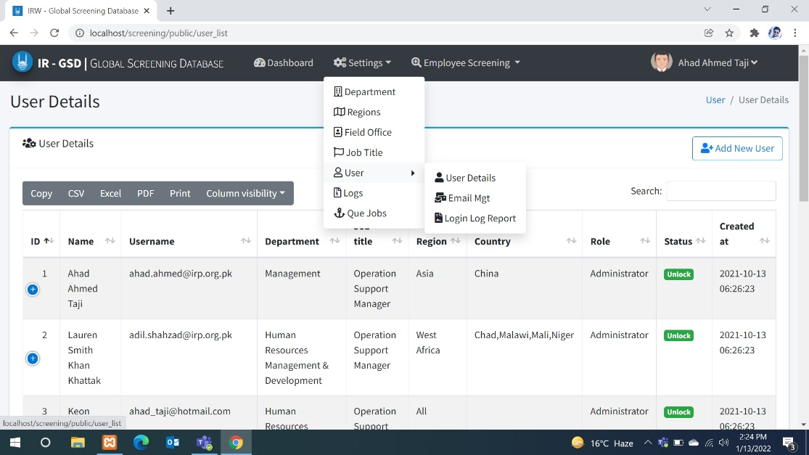

Figure 4: User menu

# User Roles and Access of Module

# Login and Forget Password

Login in to the system by using your user email and password.

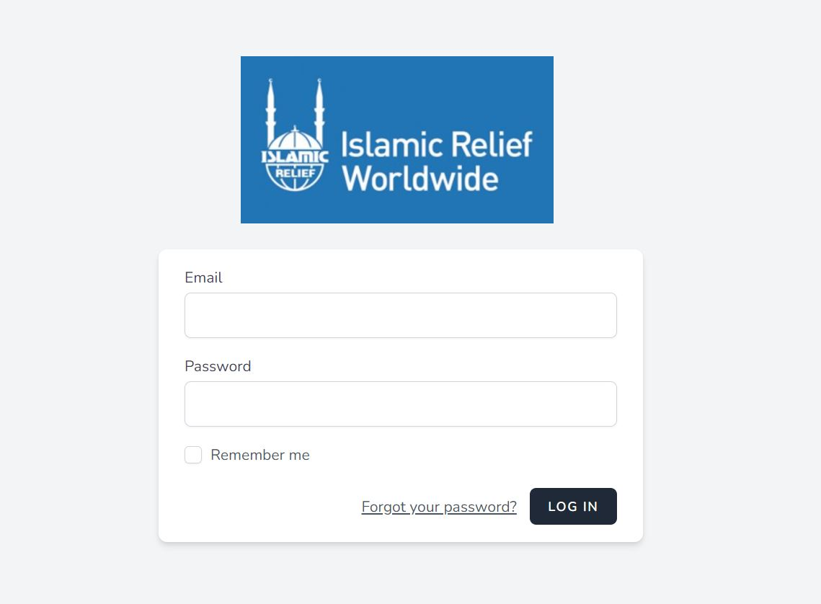

Figure 5:Login

If you forget your password you can click on “Forget password” link. A reset password link will sent to your define email address, where you can set your password again.

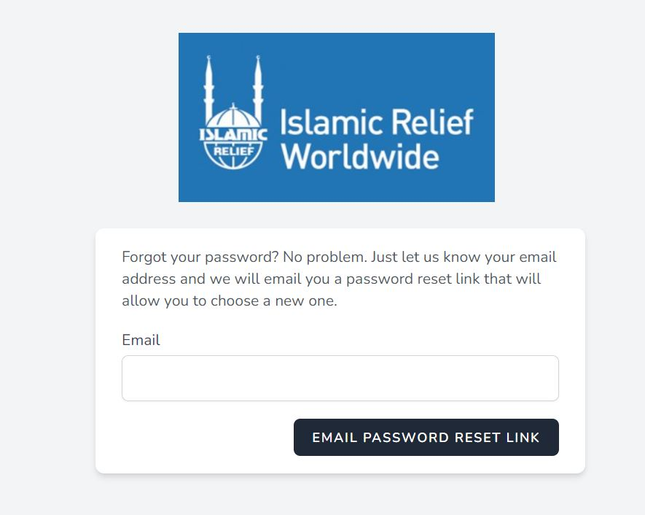

# 

# Dashboard

When you logged in the system, first you see the dashboard, where all data represents in chart and figures form. This Dashboard data based on your user id access. Means if you have access only Yemen field office the all data is related to Yemen. 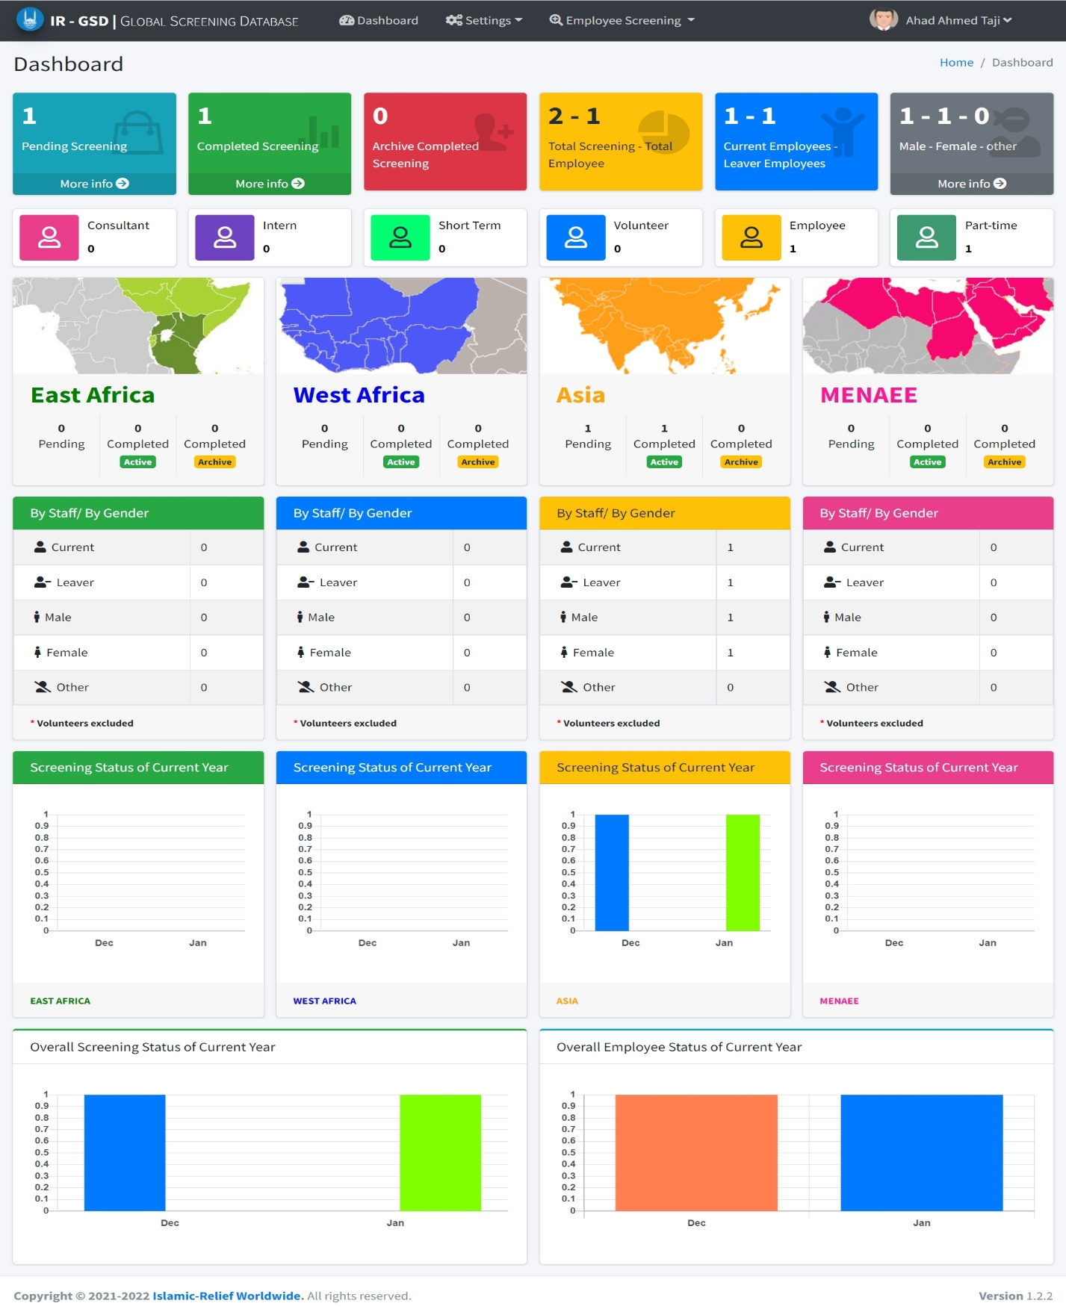

Figure 6: Dashboard

Top bar all menu shown in as above pictures. For logout or change password button shown on top right bar under the user name.

****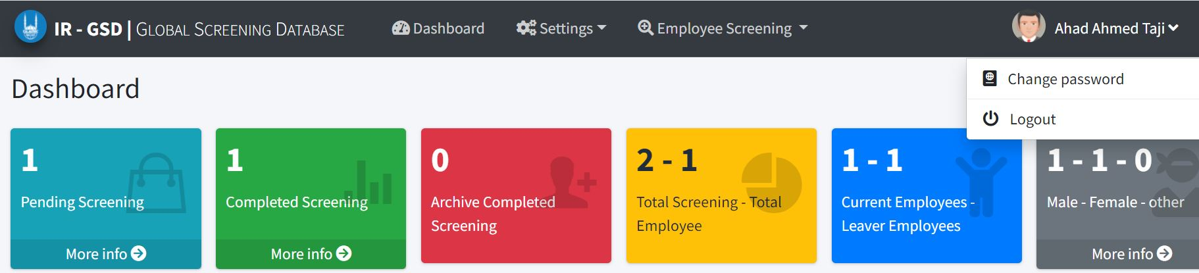

## Settings Menu

### Department, Region, Field Office and Job Title:

Administrator User can add, edit, or delete the department. Operator can only see the list of departments. This will allow you to enter new department if it is not exists.

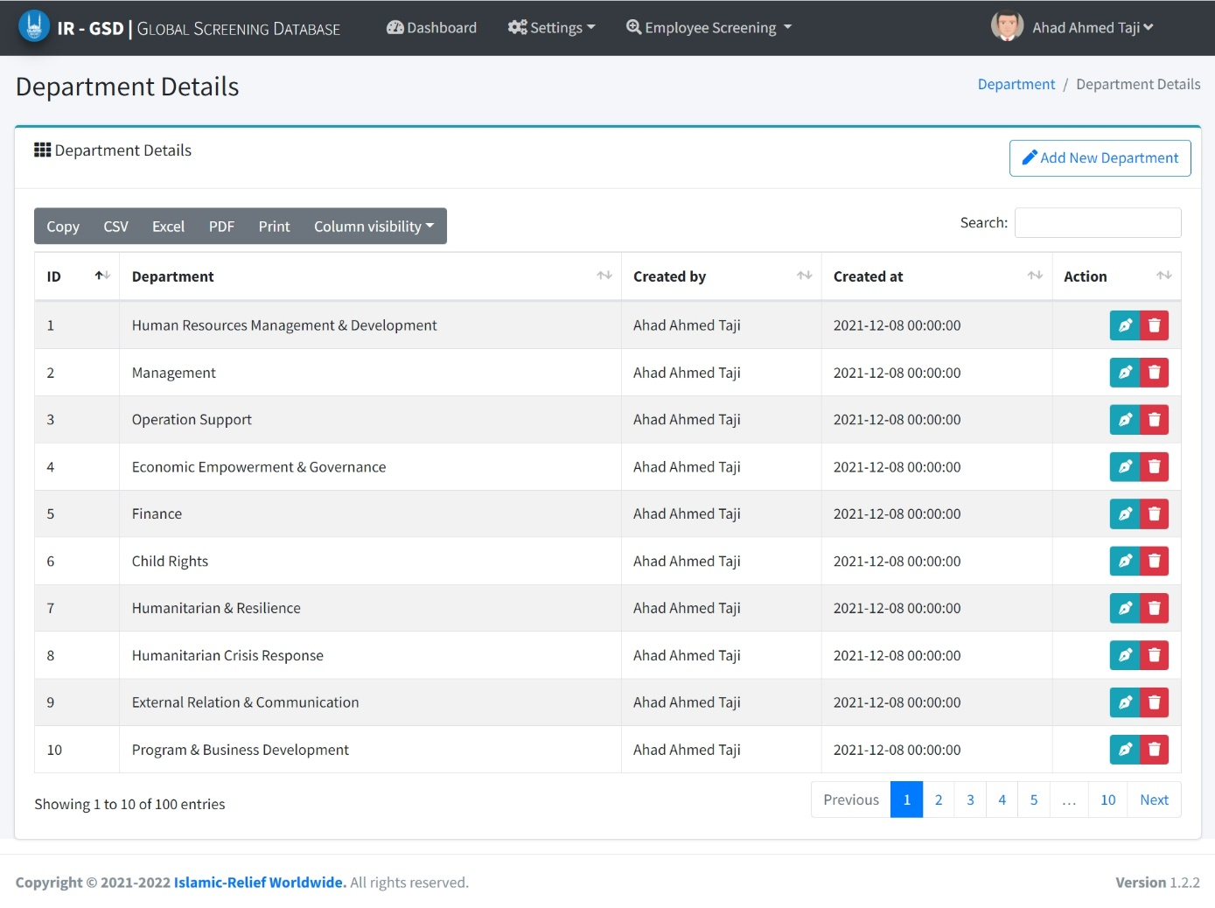

Download Excel

Figure 7: Dept list

You can add department by click on “Add Department” button. Edit the record by click on edit button on each record.

****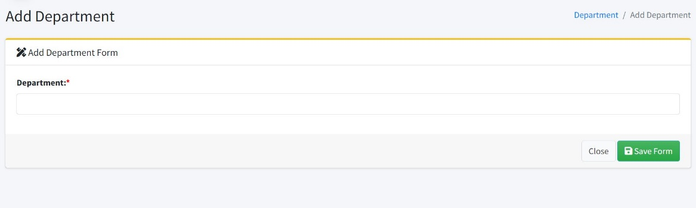****

****On deleting the record system will ask you the confirmation and if you confirm it system will delete the record and gives you the pop-up message.

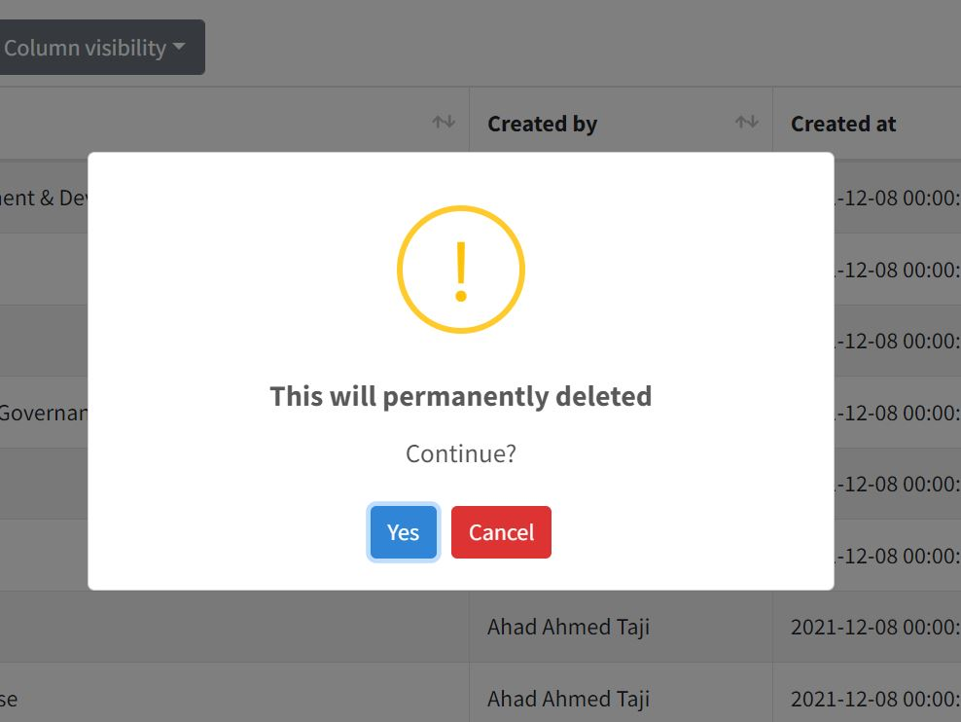

Figure 8: delete dept

### User Management

Administrator can add new user, edit user and delete the user. Admin can also locked the user id, so by this locked user cannot login. Admin can also manage the email alert management (which user receive email alerts and what type of alert user wants).

****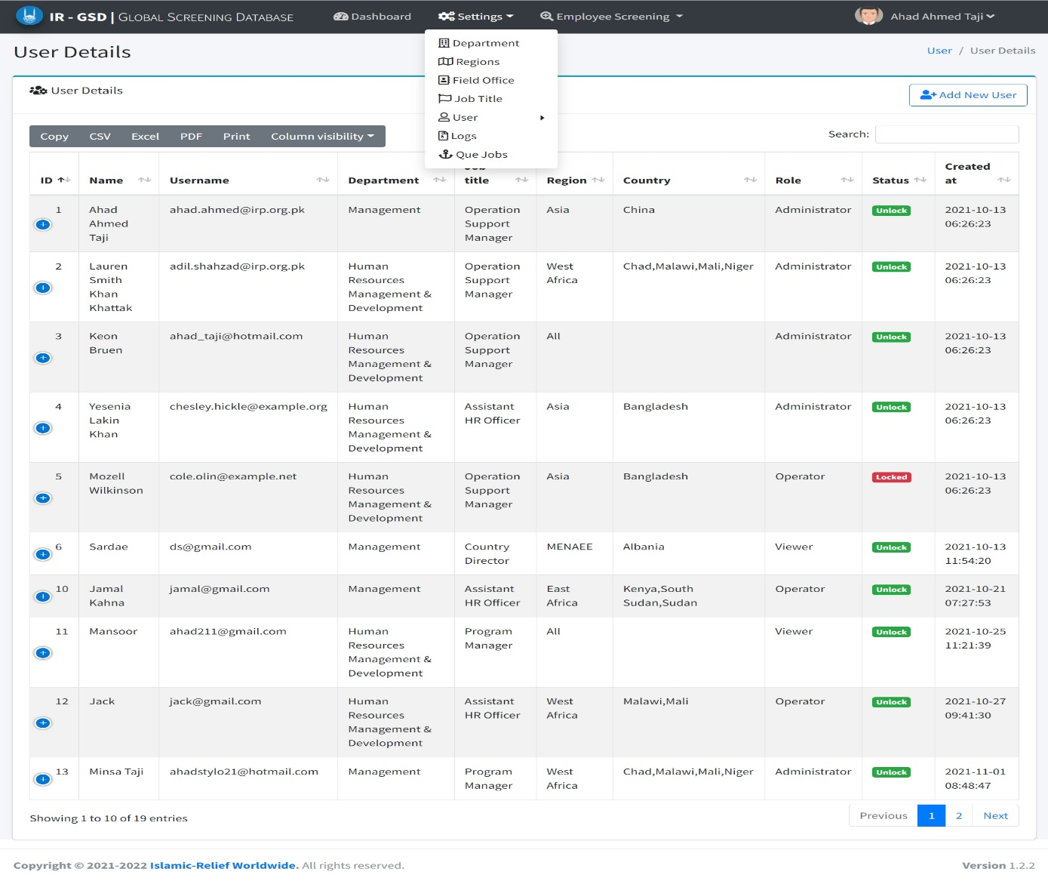

##### Add user

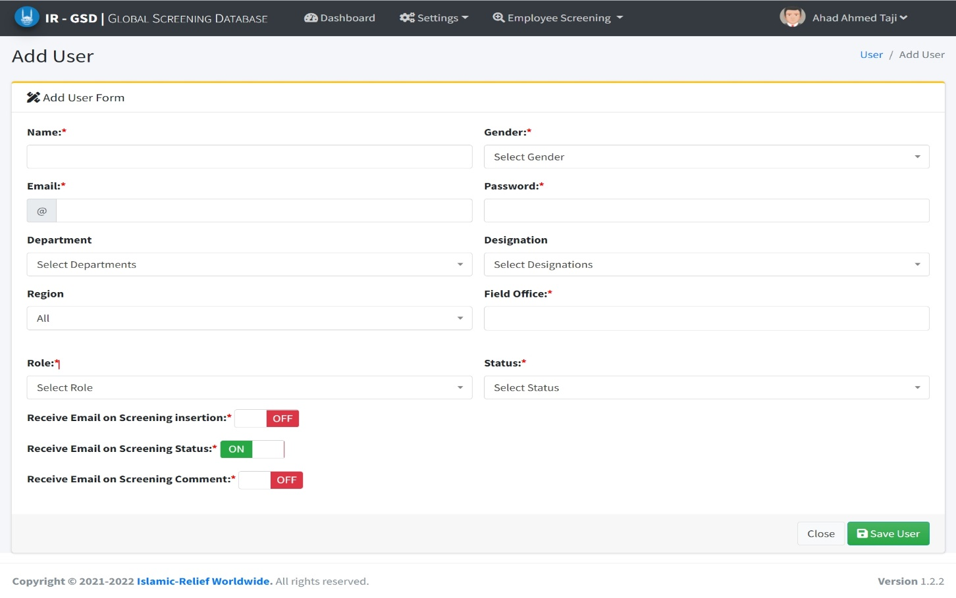

****All field are mandatory. The last section, enable you the email management. Which user want email from which action.

*Note: If user will see all regions data then select “ALL” option and no need of selection of field office. If user belong to any one region then select field office or field offices (if responsible for one or more field offices) as shown in below picture.*

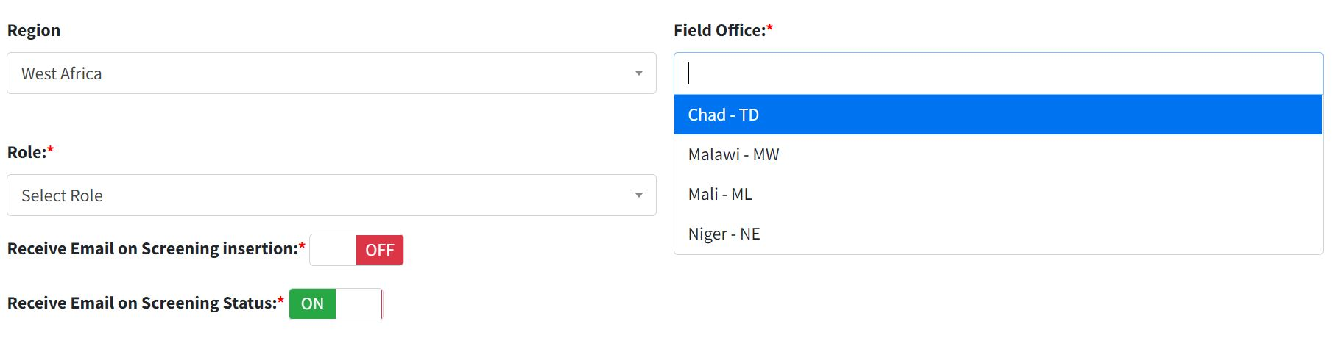

Administrator can see the email management. Which user can have the access of receiving e-mails.

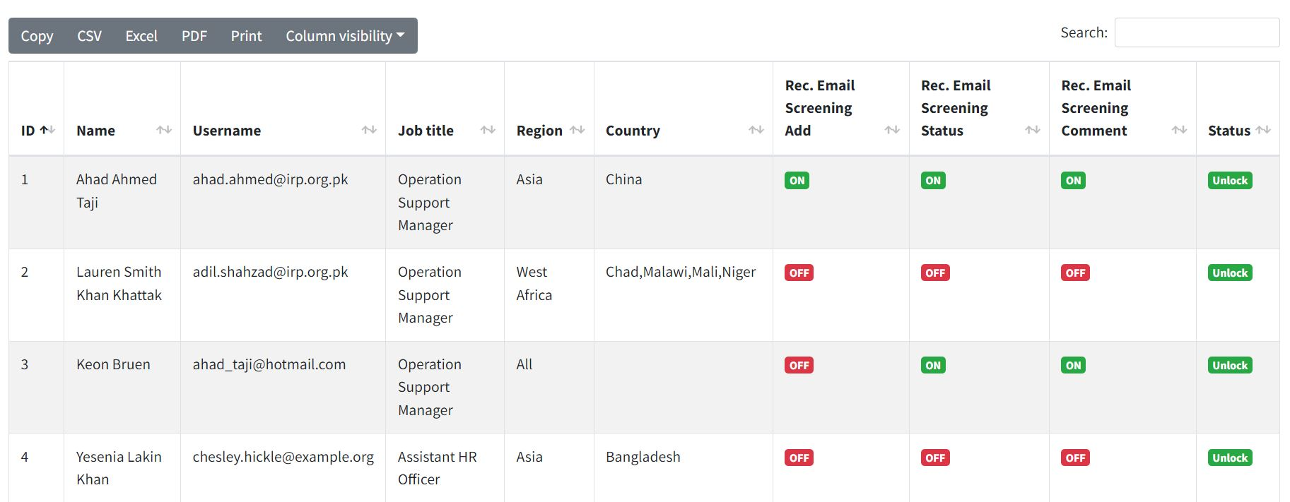

# Screening System

Steps to follow:

1. Add employee (if not exists)
2. Add screening data of employee
3. Attach necessary documents
4. Status mark when screening complete

By clicking on top bar menu “Employee Screening”, you will be viewing below screen.

****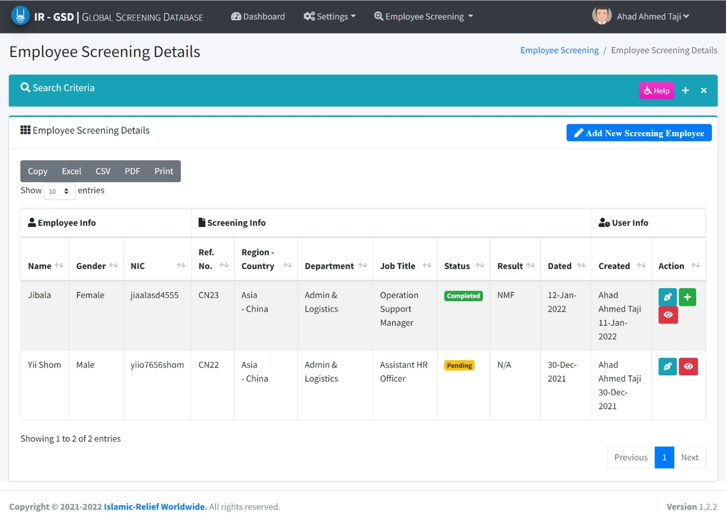

Figure 9: employee screening

You can search the employee or any screening of an employee by using search filters. Search filters will open by click on “+” button beside the help button as shown on above picture.

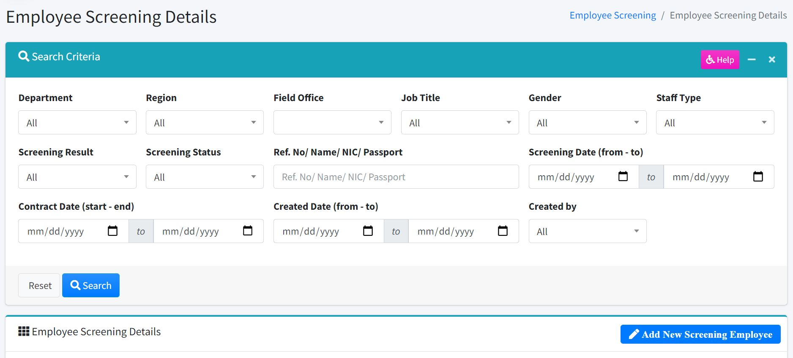

Step-1

You have variety of filters, search on NIC, Name, Reference No., department, Gender, Job Title, Region etc. In region and field office filter, option appear as per user allocation.

Like if user has the access of West region and Mali field office. Then these option will appear in said filters.

If you click on search button, data will automatically fetch record as per user allocation. User could not search other region data.

### Add Employee

Field Office user (Operator) can add new employee. By using search, he/s could search if employee exists.

If employee not found then click on “Add New Screening Employee” in order to enter the data of new employee. Fill the form.

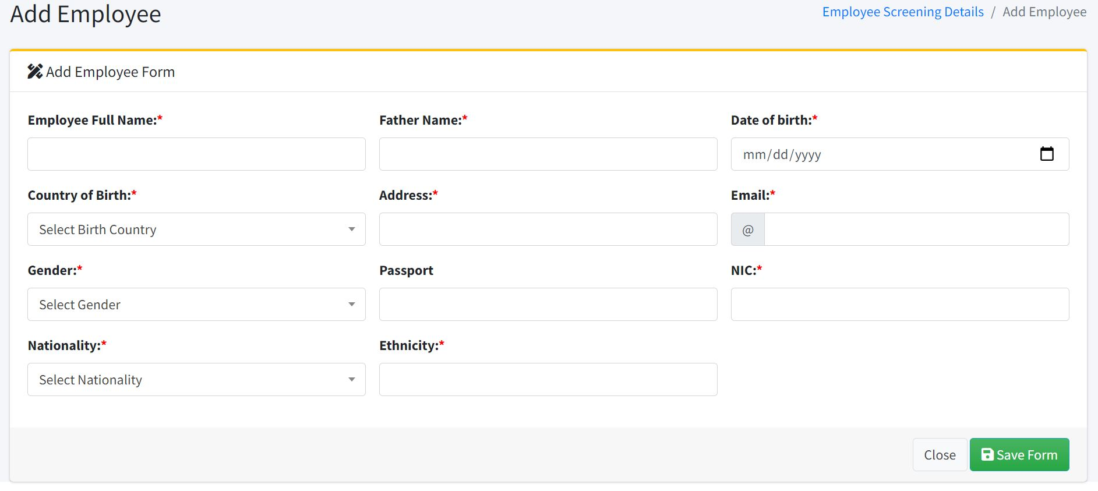

All field are mandatory except passport. As you may enter either NIC (National Identification Card) or Passport. After saving the form record will appear in the screen and marked as “Not Screened”. If you have a access of all region and you are filling the form Employee Screening then record will appear otherwise record will appear in the “Missing Employee Screening Detail” option. This option is on top bar menu as shown in figure 3.

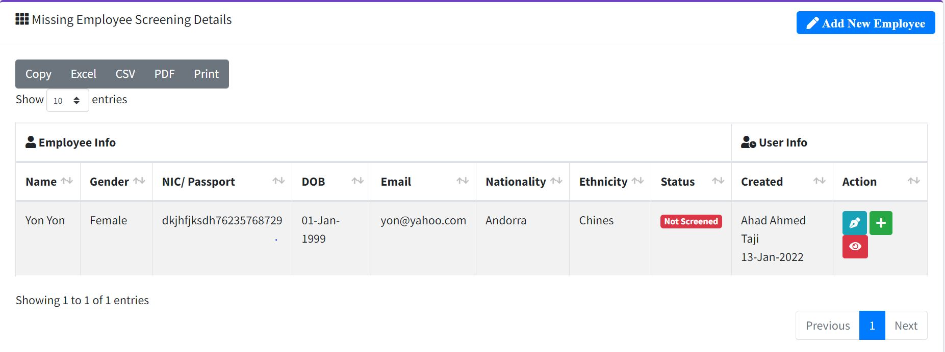

Step-2

You can edit the employee details by click on light blue pen button.

You can enter the screening detail by clicking on green “+” button either you can view employee details by clicking on red eye button.

### View Employee Details

Click on “Red Eye” in order to get see the details of employee and its screening record.

****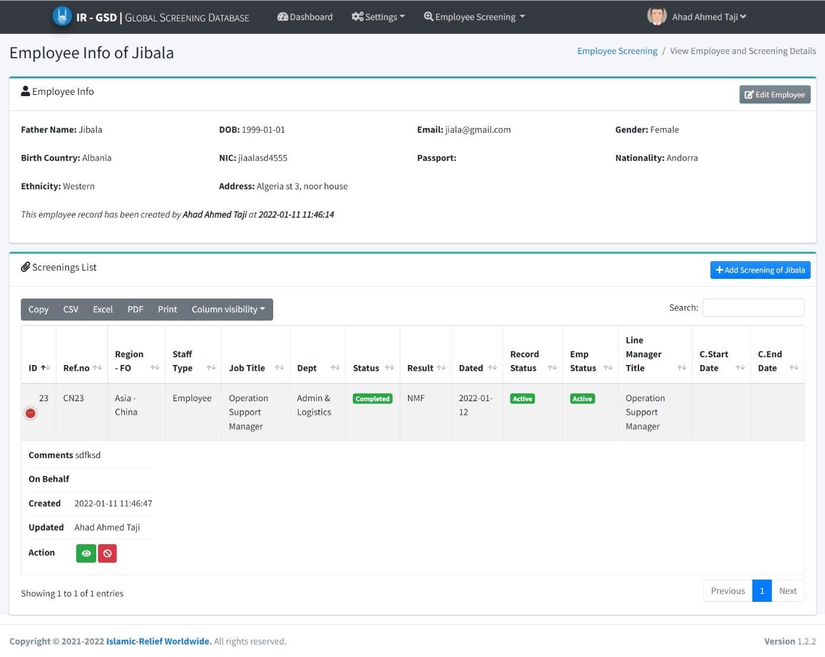

Mark Leaver

Step-3

Figure 10: employee detail

*Note:*

1. *If entered employee is new then “Add New Screening” button will show you.*
2. *If employee added and its screening is marked as completed just like shown in above picture then if click on add new screening, after entering new screening, old screening record status will be marked as “archive” and new screening record marked as “pending”.*
3. *If screening is in pending status, then you can’t add new screening further until the previous screening marked as completed, even “Add new Screening” button will disappear and display a message that screening is under process as shown in below picture.*

*****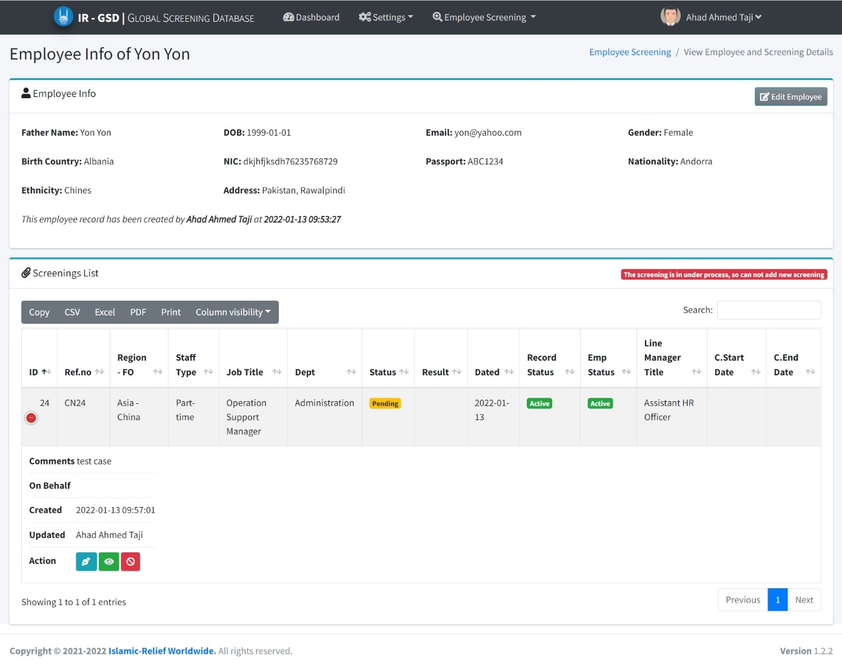*

### 3. Add New Screening

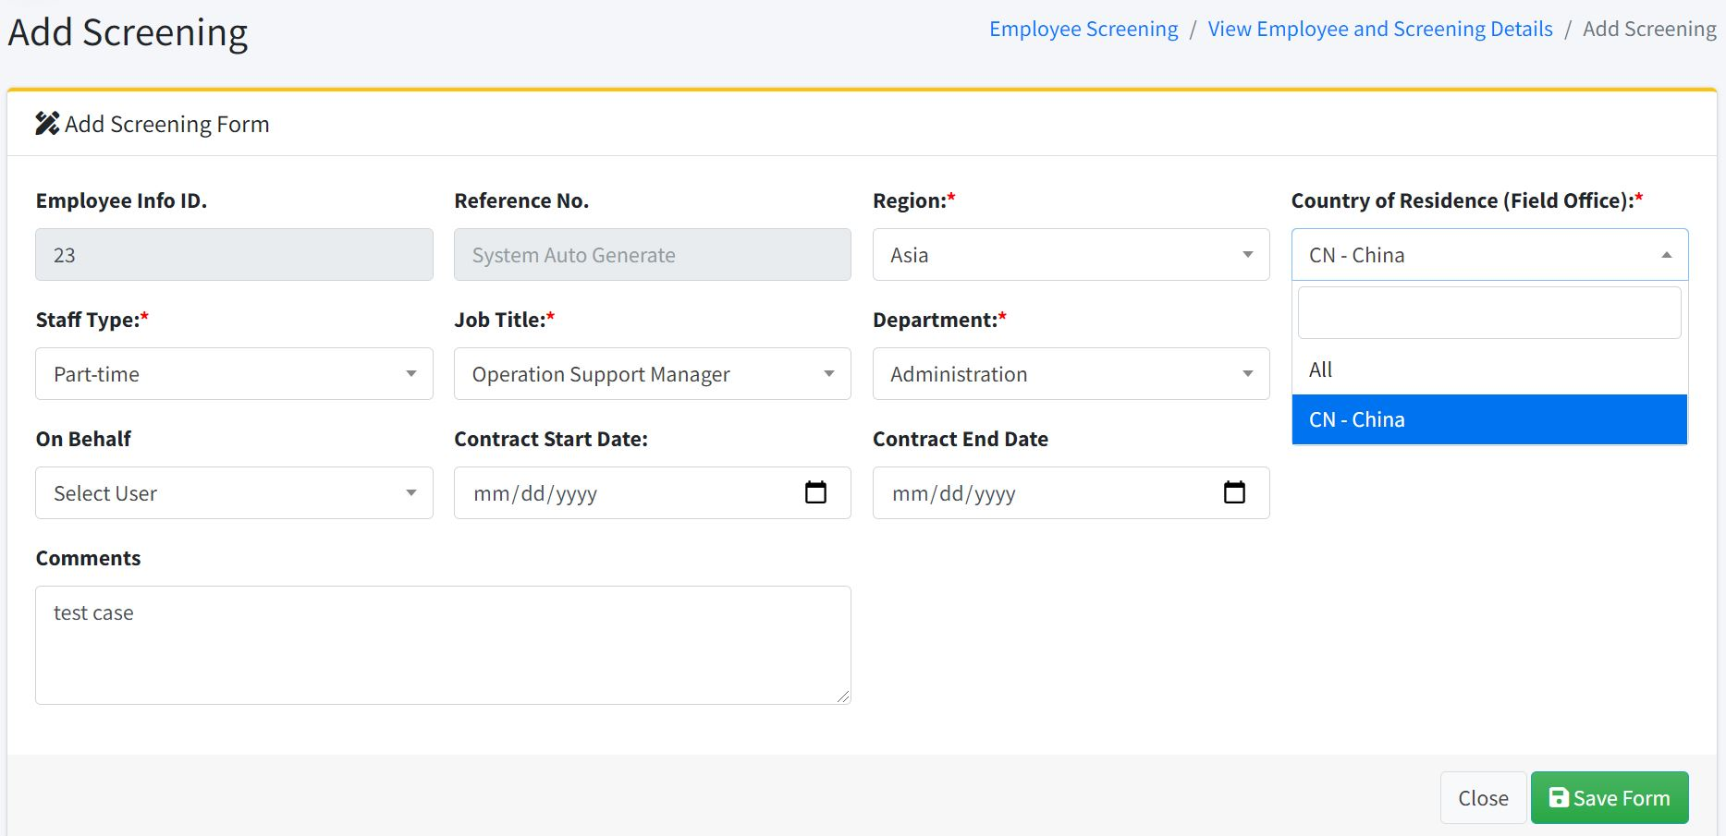

Figure 11: add screening

All field are mandatory except contract dates as that time no job offer made. On Behalf user fill when user is enter screening on behalf of other user otherwise this field is not mandatory.

Again Region and field office will appear the option as per user allocation.

Reference no. will generated by system which is unique for each screening.

****After submit “Save Form” screening marked as “Pending” and system will redirect you the next screen where you can see the details of employee and screening.

You can attach Passport / NIC document and its expiry date as per given instruction and attach necessary document as per policy or any request by senior management.

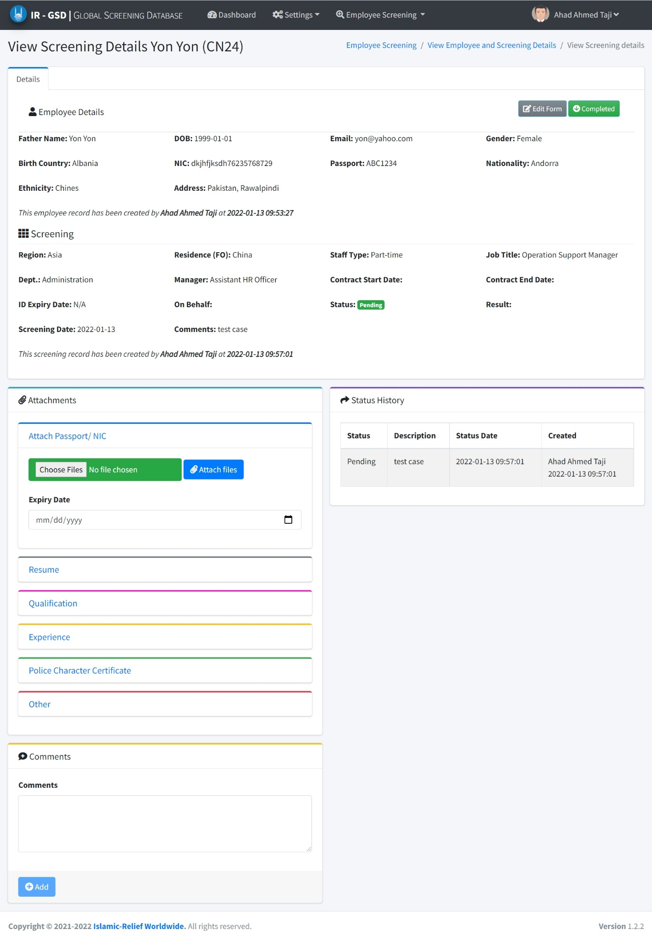

Step -4

Step-5

Figure 12 screening detail

### 4. Attachments

You can attach Passport/ NIC as per given instruction and it’s expiry date. You can attach resume, qualification documents etc. or you can ask your manager by writing on “Comment” section regarding any query of this screening or any attachment required.

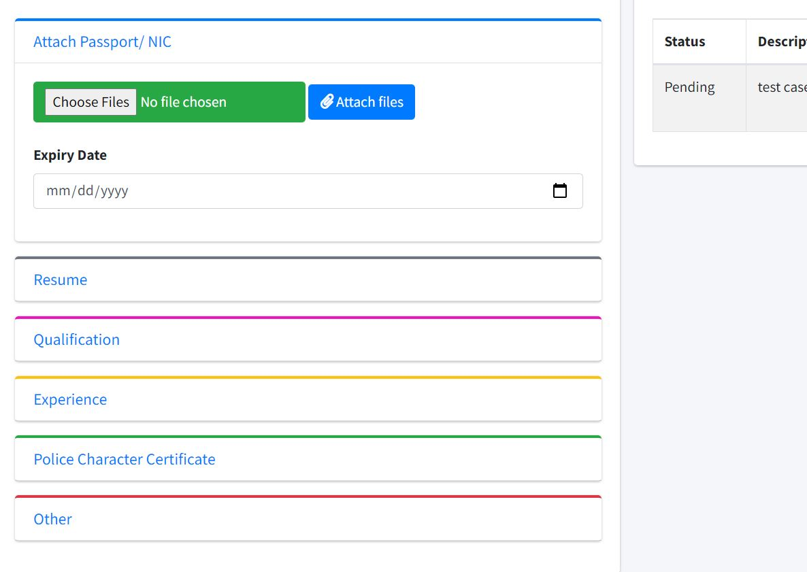

After attaching you can download that attachment, system will show the information that who attach the picture and when. You can delete the attachment if you mistakenly attach wrong document.

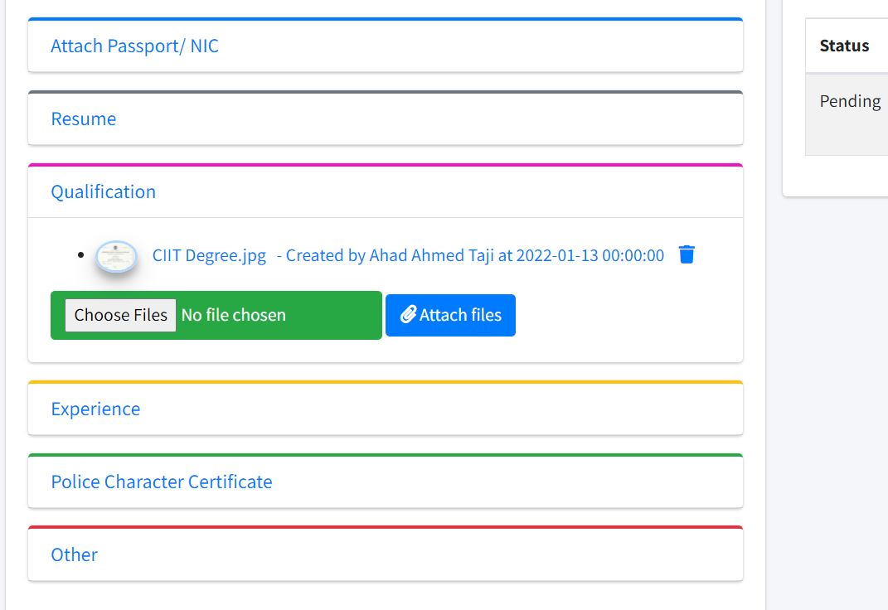

In case of any query or any other document required, you can mention comment on screening and it will send the email alert also.

****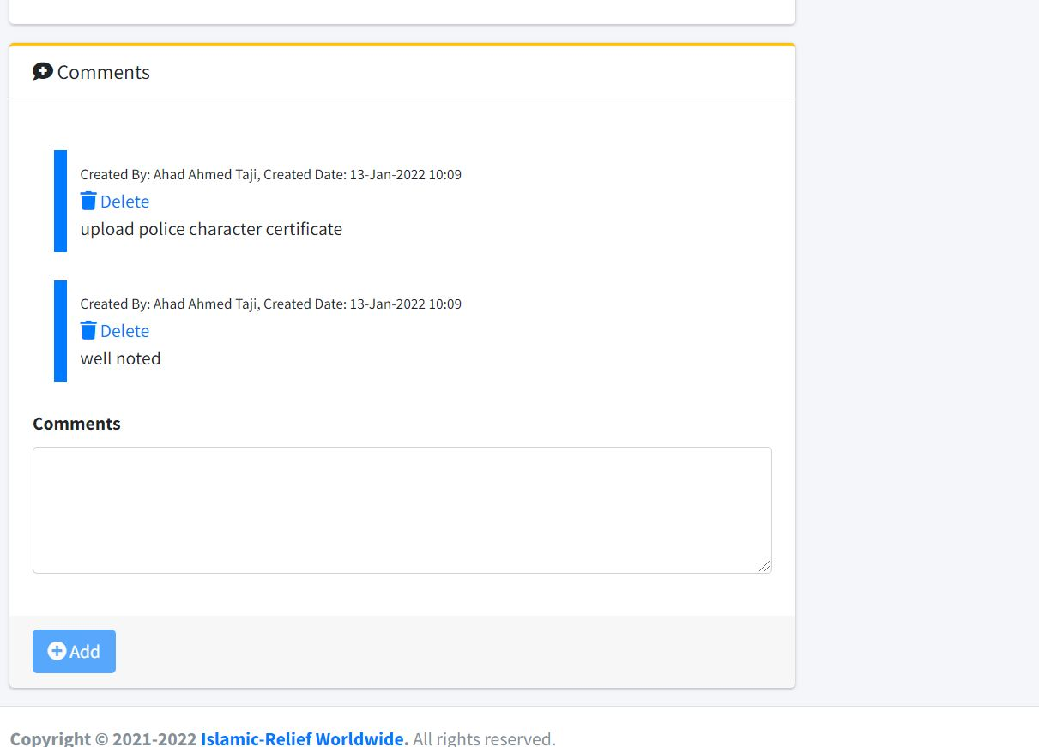

### 5. Mark Completed Status

After verifying record from Thomsan Reuter, Screening mark as completed and capture the details of screening result and date. Click on green button named “Completed”. It will show you a dialog, fill data and save it.

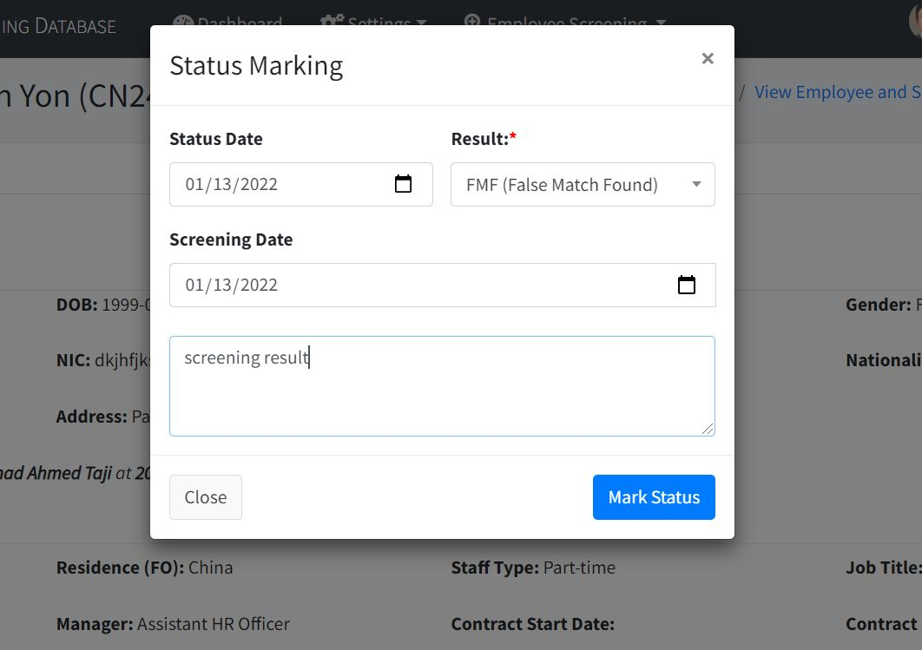

Figure 13: status marking

****After that screening marked as Completed and status converted as shown in below picture.

In previous screenings, status shown as per current status. Edit of screening will not allow if screening is completed except the contract dates when user joined.

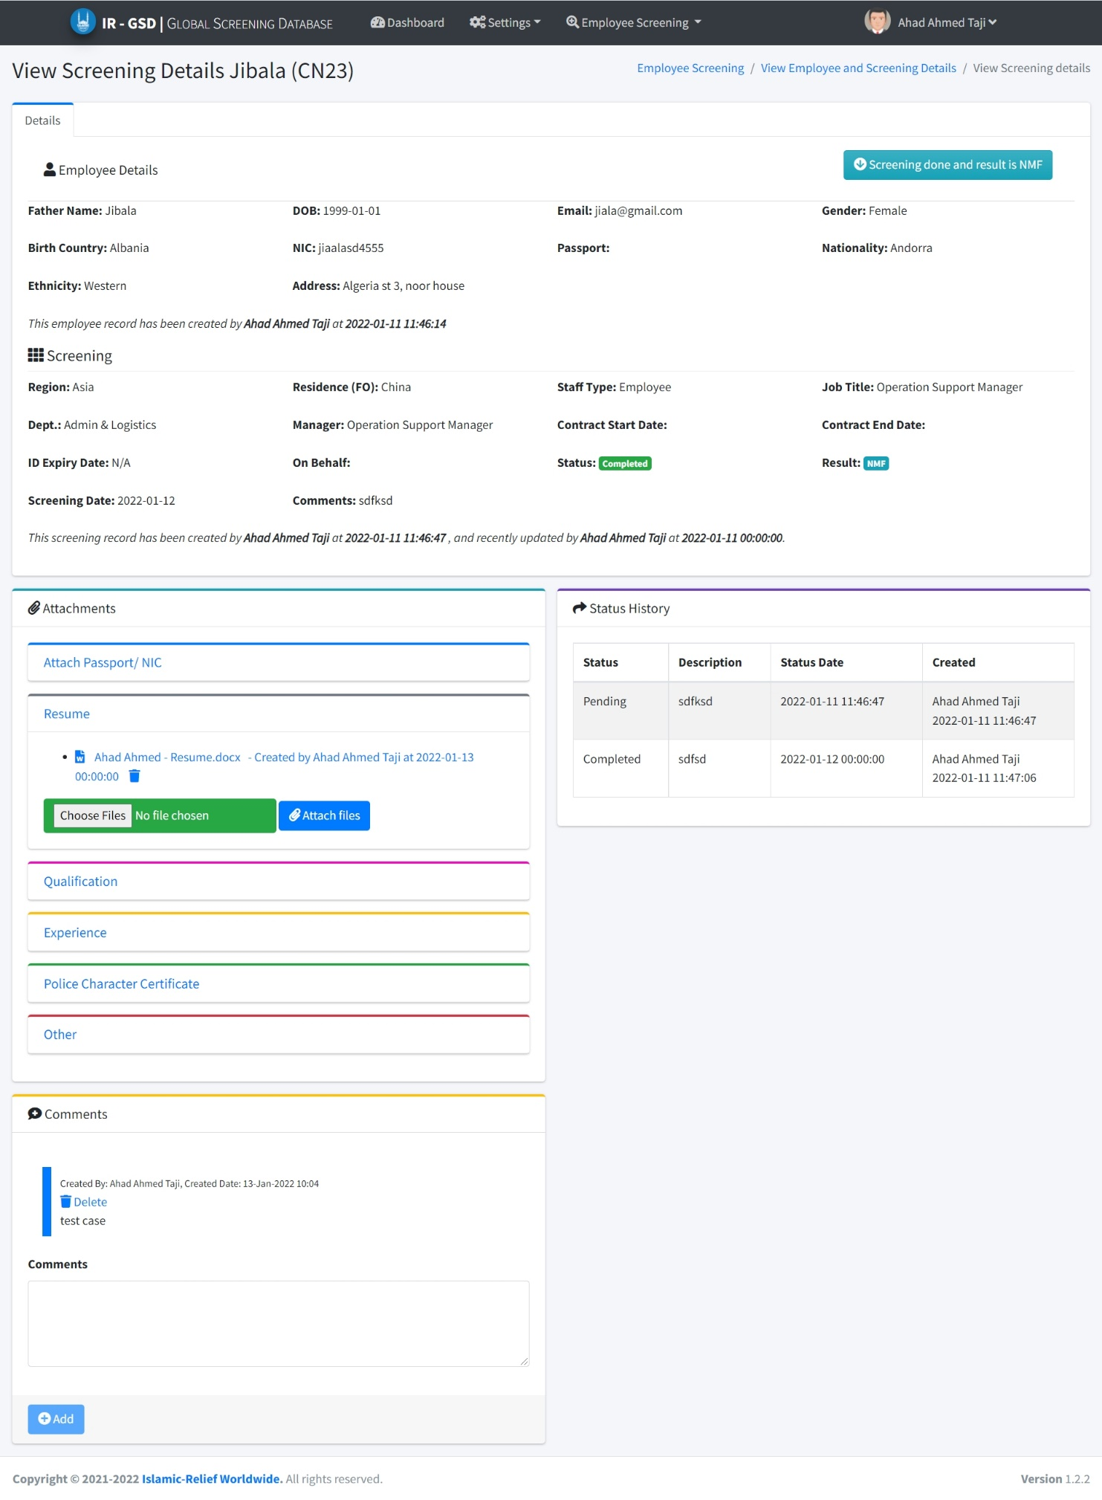

Figure 14: completed screening

****Note: after screening completion and staff accepted the job offer, kindly Operator (field office User) update contracts dates by editing the screening details.

## Mark Leaver

User can mark the employee as Leaver when staff resigned or left by any reason.

You will find this option while viewing the employee details as shown in figure 10. Click on “Red Ban” button and capture the details of last working date.

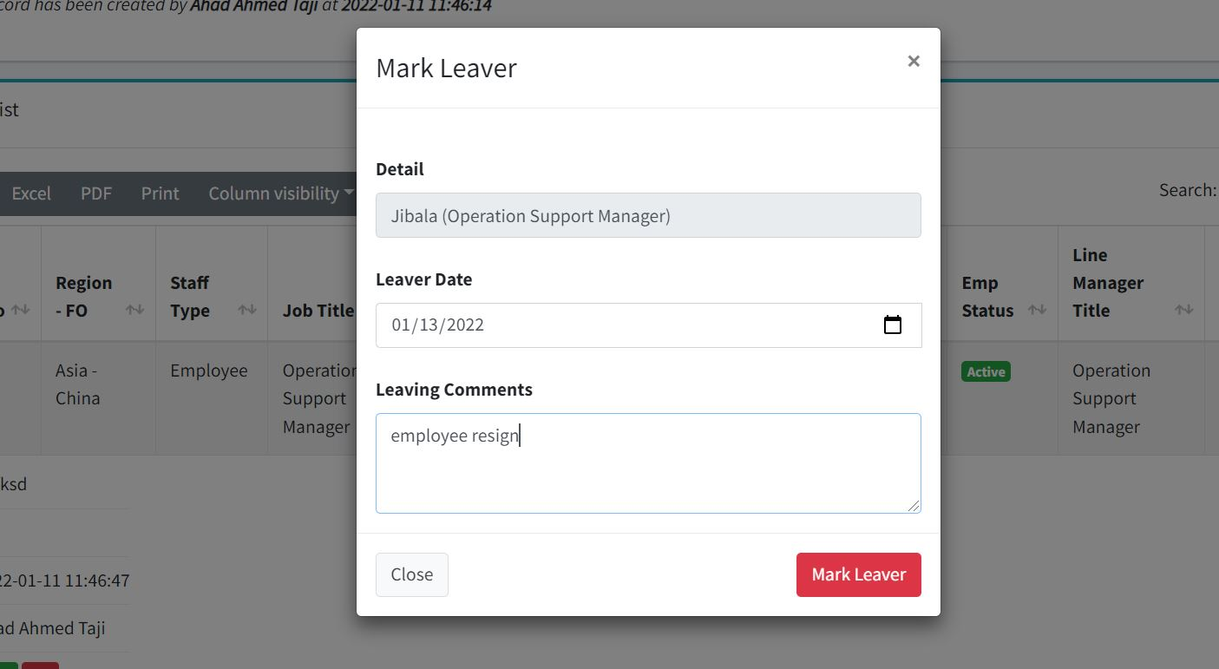

Figure 15: Mark leaver

## Email Alerts

This system send emails to those users who has allow to receive the emails. There are four type of emails:

1. Email send while screening add – this email sent once in a day, every day system check for new screening and at midnight system will notify the users accordingly.
2. Email send while status marking – email sent to operator in order to notify that screening has been completed and take further actions.
3. Email send while comments – if any comment mention on screening by user system will send the email to particular user which belong to that region.
4. Email send while mark leaver – when operator mark the employee as leaver then system will send the email.

****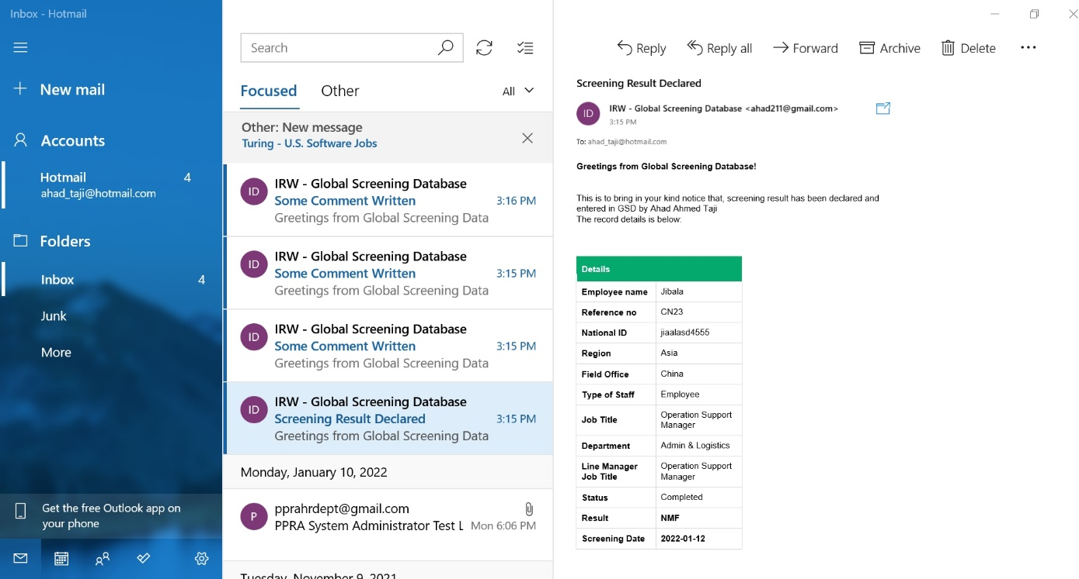

***______Thank You_____***